1. One last quick thing around the entire image building process which you will not use very often or ever but will help you get a better handle on the relationship b/w an image and a container.
2. 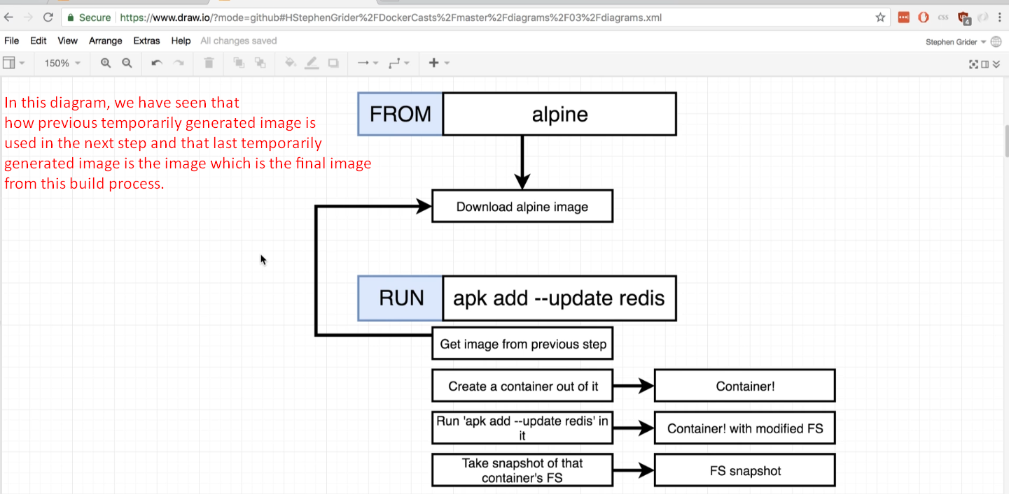
3. 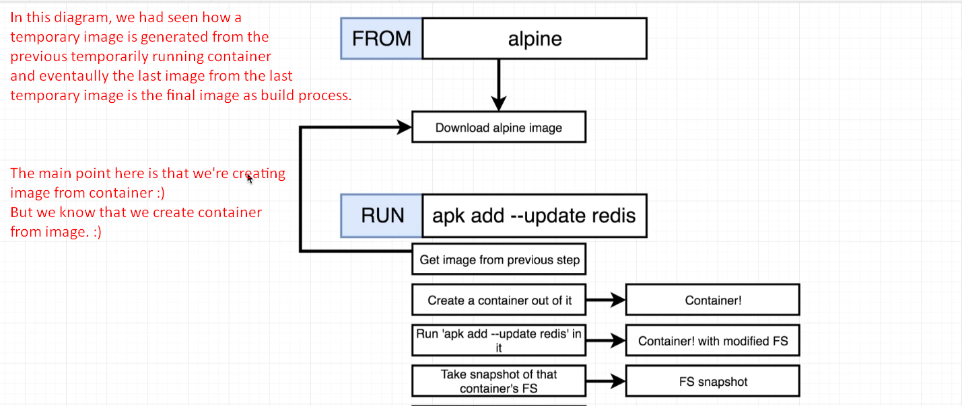
4. 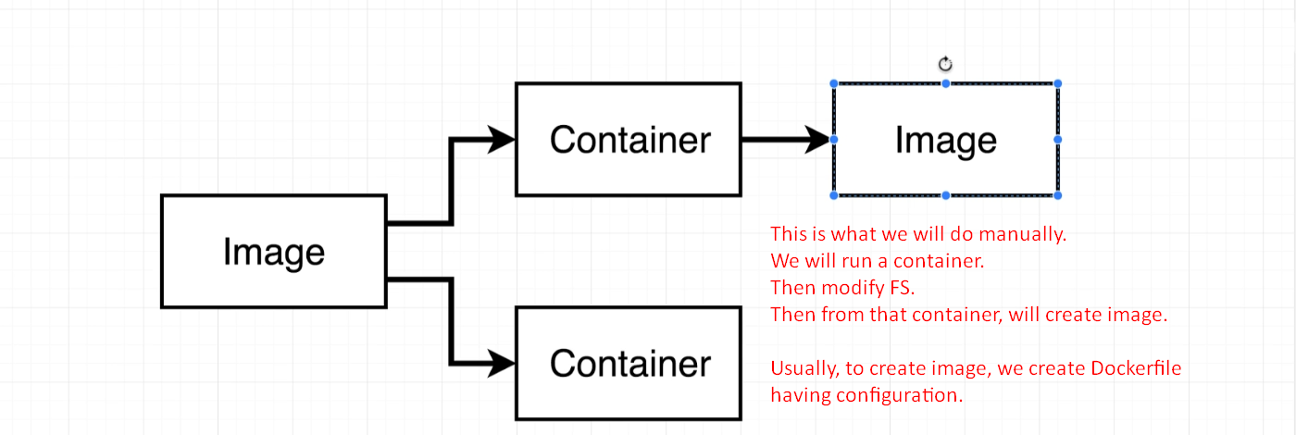
5. 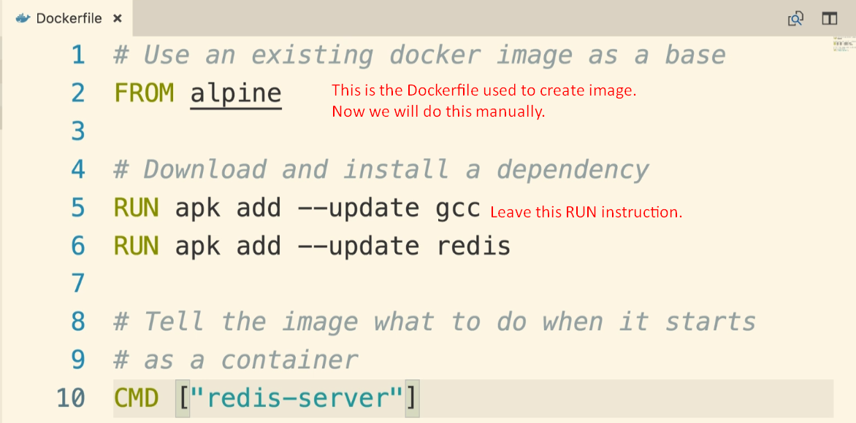
6. 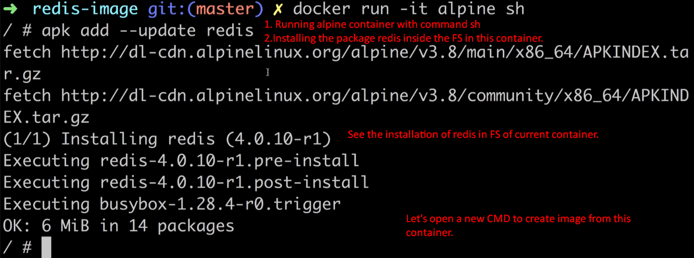
7. Now we’re going to run a command through CLI that does the followings
   1. Takes the snapshot of File System of current running container.
   2. Sets up the default command.
   3. Then eventually generates an image out of this entire thing.
8. 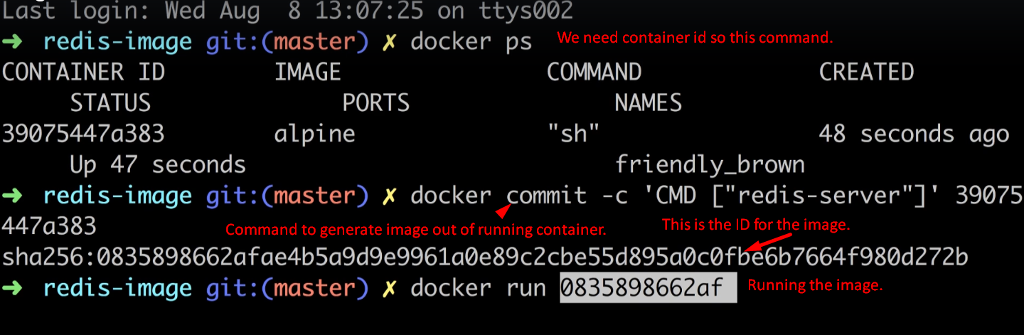
9. 